ASSIGNMENT 1

A) SALESPEOPLE

|  |
| --- |
| Snum int(4) |
| Sname varchar(10) |
| City varchar(10) |
| Comm float(3,2) |

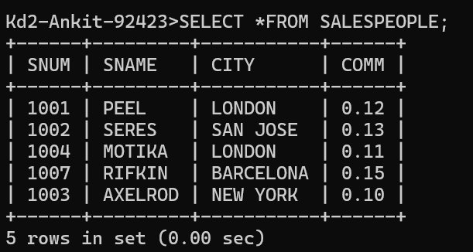

B) CUSTOMERS

|  |
| --- |
| Cnum int(4) |
| Cname varchar(10) |
| City varchar(10) |
| Rating int(4) |
| Snum int(4) |

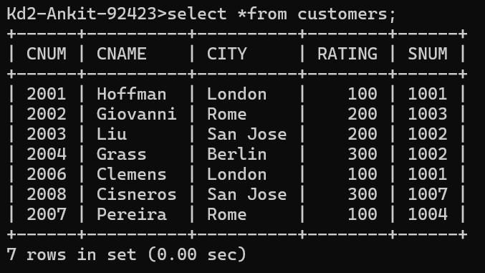

C) ORDERS

|  |  |
| --- | --- |
| Onum | int(4) |
| Amt | float(7,2) |
| Odate | date |
| Cnum | int(4) |
| Snum | int(4) |

